**Q: Timmy is floating 10m from his spaceship. He only has a screwdriver. Explain, with reference to momentum, how can he get back to his ship.**

Timmy must throw the screwdriver away from the ship. Since the initial momentum of the system is zero the final momentum will also be zero. The impulse Timmy applies to the screwdriver will be equal and opposite to the impulse applied by the screwdriver to Timmy. By giving the screwdriver momentum away from the ship, Timmy gains momentum towards the ship.

**Q: A computer in a space probe needs to be shielded from ionising radiation. Suggest how this could be achieved and discuss any limitations of your suggestion.**

A few cm of lead around the computer will effectively shield it from alpha and beta radiation but there’s no practical way of effectively shielding it from gamma radiation, because it’s highly penetrating, as it would require too much mass for a space probe. This may be okay since gamma is the least ionising form of ionising radiation.

**Q: Explain the difference between ionising radiation and radioisotopes.**

Radioisotopes are unstable isotopes which eject particles and/or electromagnetic waves to become more stable. This is referred to collectively as nuclear radiation. Ionising radiation is alpha, beta and gamma that causes exposed particles to become ionised.

An imbalance in the currents between the active and neutral wires suggests that there’s some earth leakage with that current flowing to earth.

A short circuit is a fault in the circuit that connects the active and neutral wires, effectively bypassing the load in the circuit. This means there’s a greatly reduced resistance due to the absence of a load, causing a high current to flow. This condition will trigger a circuit breaker.

**Q: Explain why some household electrical appliances have plugs with 3 prongs whilst some only have 2, yet both are safe.**

Plugs with 3 prongs have an active, neutral and earth pin. The connection of an earth is required when there’s any possibility that the active lead could contact the metal casing of an appliance and risk of electrocution as users become the contact to earth. Some smaller devices are double insulated and so the active wire can’t deliver charge to any part of the device that a user can touch. In this case, the earth isn’t needed, and the plug can safely have only 2 prongs.

**Q: 2 slow-moving protons are travelling directly towards each other. Will the protons collide and fuse together? In your answer make reference to the forces acting on the protons and the energy barrier.**

Electrostatic forces of repulsion act on the protons. They don’t have enough energy to overcome this force to get close enough for the strong nuclear force to come into effect and hence won’t fuse. These protons haven’t jumped the energy barrier.

**Q: 2 slow-moving protons are travelling directly towards each other. The protons collide and fuse together. Discuss the forces that act on the protons and make reference to the energy barrier in your answer.**

Electrostatic forces of repulsion act on the 2 protons initially but the protons have enough energy to push past these forces and get close enough together for the strong nuclear force to take effect. This force enables the nucleons to fuse. These protons have overcome the energy barrier.

Fe-56 has the highest binding energy per nucleon. This means Fe-56 atoms require the most energy pr nucleon to break up their nucleus and so they’re the most stable.

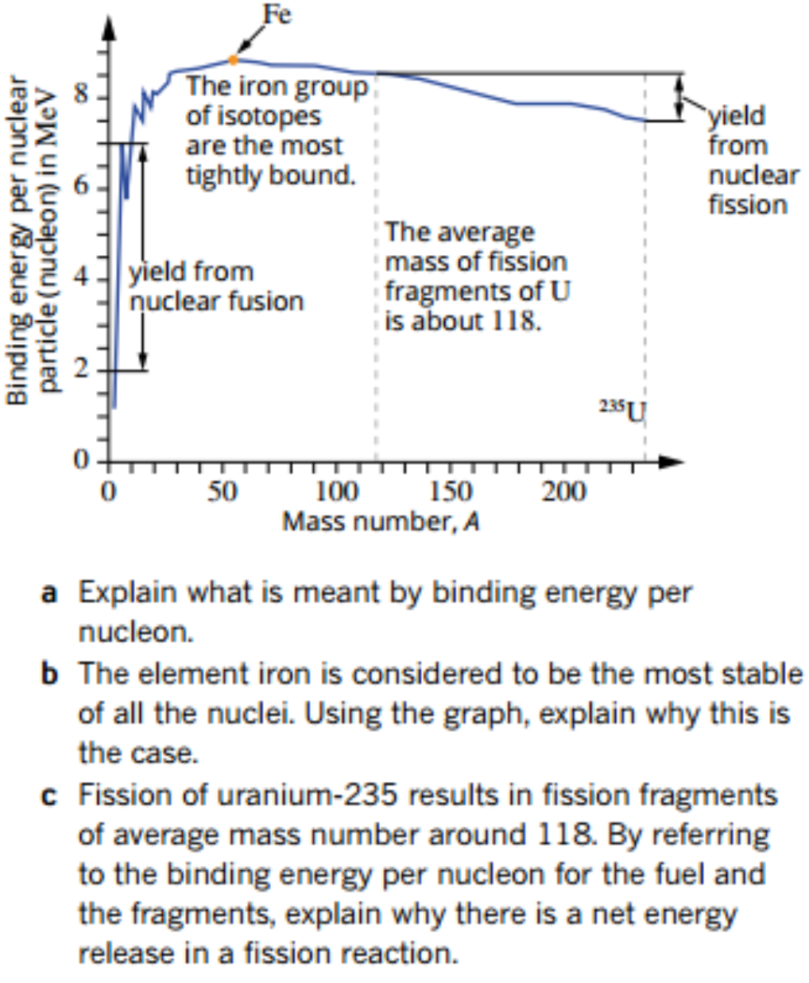

**Q: Fission of U-235 results in fission fragments of average mass number around 118. By referring to the binding energy per nucleon for the fuel and the fragments, explain wy there’s a net release in a fission reaction.**

The energy per nucleon for uranium is about 7.5 MeV and the binding energy per nucleon for fragments of mass number 118 is about 8.5 MeV. That means that when the smaller fragments are formed, they’re more tightly bound and the difference in energy is released in the fission reaction. This is about 1 MeV for each nucleon.

**Q: An engine pulls a line of rail cars along a flat track with a steady force, but instead of accelerating, the whole train travels at a constant velocity. How can this be consistent with Newton’s first and second laws of motion?**

The steady force applied by the engine is equal and opposite to the combined resistance forces such as air resistance and friction between the wheels and track. The net resultant force on the carriages is zero and according to Newton’s first and second laws constant velocity will result.